





**CURRICULUM POLICY**

|  |  |
| --- | --- |
| **Most recent Review Date** | February 2025 |
| **Author** | Christopher Bailey / Claire Chambers |

Document History

|  |  |  |  |
| --- | --- | --- | --- |
| **Version** | **Comments/amendments** | **Name** | **Date** |
| 1.0 | First Version | Christopher Bailey / Claire Chambers | July 2024 |
| 2.0 | Second Version | Christopher Bailey / Claire Chambers | October 2024 |
| 3.0 | Third Version | Christopher Bailey / Claire Chambers | February 2025 |

# CONTENTS

## Section A – Intent

**A.1 Curriculum Rationale**

**A.2 Curriculum Aims**

**A.3 Curriculum Design**

## Section B – Implementation

**B.1 Curriculum Structure**

**B.2 Curriculum Delivery**

**B.3 Overcoming Barriers to Learning (WELLBEING)**

**B.4 Roles and Responsibilities**

## Section C – Impact

**C.1 Pathway Assessment**

**C.2 EHCP tracking**

**C.3 Quality Assurance Schedule**

**C.4 Reporting to Parents**

**Section A – Intent**

**School Intent**

Together at Bestwood Village School, we **ASPIRE** to be the best versions of ourselves that we can be.

* A - Achievement
* S - Safety
* P - Positivity
* I - Independence
* R - Respectfulness
* E - Enjoyment

Together we will;

* Ensure that we all achieve outcomes that are to the best of our abilities.
* Ensure we keep one another safe and that everyone feels looked after.
* Maintain unconditional positive regard in everything we do.
* Ensure that everyone feels empowered to be as independent as possible.
* Be kind and respectful to one another and ensure no one feels alone.
* Have as much fun and enjoyment as possible.

## A.1 Curriculum Rationale

Bestwood Village School is a day school for boys and girls aged 7 to 16 with a diagnosis of autism, and who have a range of complex learning needs, communication and sensory difficulties. Pupils are placed from a wide range of local authorities, and they all have an Education, Health and Care Plan (EHCP).

All our pupils have experienced significant barriers to learning, due to either their developmental profile, negative life experiences, or both. Before joining our school, many have been unable to access a school-based curriculum effectively, and many have experienced multiple placement breakdowns. As a result, pupils start their time at Bestwood Village with significant gaps in their learning, and all pupils are working below age-related expectations, many are working significantly below.

At Bestwood Village the curriculum offers planned learning experiences that every student attending can make progress against. The curriculum is delivered both formally within the context of a lesson or informally outside the classroom throughout the school day. All activities that we organise are designed to promote the learning, personal growth, and development for our pupils.

Our curriculum also incorporates opportunistic learning experiences that occur throughout the day, and which staff pro-actively seek out and capitalise on, in line with the autism specific elements of our curriculum framework.

All pupils access a dual learning experience. Firstly, based on the targets that have been defined in their EHCPs, which have been broken down into student specific Personal Learning Goals (PLG’s) for each term. Secondly, student will progress against personalised academic targets which are tracked through their individualised assessment books.

**A.2 Curriculum Aims**

Although we admit learners from as young as 7 years old, from day one our focus is on preparing them to become as independent as possible to prepare for their adulthood. Regardless of the age at which our pupils join us, our priority from the outset is to ensure they are ready for the next stage of their learning journey.

Our curriculum, therefore, is designed to prepare our pupils for life in modern Britain, and to overcome and support any barriers to learning they experience as a result of their autism, additional diagnoses, or past experiences. At Bestwood, we understand that the learning journey, personal circumstances and educational and personal outcomes for every pupil are entirely unique, and so our curriculum strives to provide pathways that match the capacity and potential of each learner.

Our curriculum is driven by the pupil’s needs and interests – underpinned by our accept develop (AAD) strategy. The curriculum is designed to allow students to make progress against targets outlined within the EQUALS curriculum, elements of National Curriculum, the PSHE Association Planning Framework for Pupils with SEND and the Autism Education Trust’s Pupil Progression Framework. Our curriculum is broad and varied and provides pupils with rich learning experiences that are highly personalized.

We are committed to core British Values, including democracy, the rule of law, individual liberty, mutual respect for, and tolerance of, those with different faiths and beliefs, and through our RSE curriculum we actively promote our pupils’ understanding of and respect for a diverse range of people, especially those who belong to groups susceptible to discrimination.

As a school for children with autism, one of our aims is that pupils make the maximum progress possible in the areas of difficulty typically associated with that diagnosis, including their social communication, emotional regulation, and sensory processing. Our curriculum also aims to ensure pupils can both sustain and generalise the skills they acquire, over time, and across different contexts and circumstances. Above all, our aim as a school is to ensure our pupils leave us with the highest possible levels of independence and autonomy, whether that be through the acquisition of practical and academic skills, regulation of their own sensory and emotional needs, or effective articulation of their own choices and pursuit of their own interests and life goals.

Given the diversity of needs and strengths across our pupil population, we aim to establish and sustain the very highest standards of teaching and learning in order that gaps and specific areas of challenge can be addressed and where possible overcome. There are three key factors within our control that will enable us to do this.

These are:

1. The **Environment.** The physical environment (and the resources within it) must be carefully designed and managed to actively contribute to pupils’ learning. We aim to provide a therapeutic, supportive and nurturing environment for everyone. Sensory needs of learners are highly considered within the environment.
2. Our **Expectations.** The level, type and volume of work in any activity or lesson must be specifically tuned to the needs and abilities of individual learners. Expectations placed on pupils must build on their previous experiences and promote the highest possible level of progress from students highly individualised starting points.
3. Pupil **Experience.** Engagement is key to successful learning. Where possible we draw upon research within NAS, Attention autisms and our own strategy of AAD – (Ask, Accept Develop) and TIP (Trauma Informed Practice), our curriculum, therefore, is predicated on the **wellbeing** and **involvement** of all pupils.

## A.3 Curriculum Design

Our pupils require us to have an agile reflexive approach to curriculum design. The need for our curriculum to be flexible, adaptable and robust enough to meet the ever-changing demands of the modern world, and best prepare our pupils for a life within it, is the cornerstone of this policy, and our curriculum will also be shaped by and adapted to the needs of our diverse and changing pupil population.

The curriculum and teaching and learning approaches used are designed to reduce barriers to learning and ensure good progress and positive engagement. It is the expectation that all pupils will access a curriculum which supports them to fulfil their potential. Approaches used to plan and deliver the curriculum are devised to meet the needs of individual learners, for some this will be through specialist subject focused approaches. For others it is more appropriate to base approaches on a suitable personalised framework.

The learning experiences are carefully planned and structured to ensure continuity and cohesion so that that each pupil is enabled to make the very best progress in the development of their knowledge and skills.

As described above our planning is driven by pupil’s needs and interests and is informed a combination of the EQUALs curriculum, elements of the National Curriculum, Development Matters, PSHE Associations planning Framework for Pupils with SEND and the Autism Education Trust’s Pupil Progression Framework.

The Senior Leadership Team are responsible for monitoring the planning and delivery of the curriculum utilising a quality assurance framework (See QA policy). This monitoring is organised into an annual timetable of deep dives, alongside short reviews and audits, training and development as well as outlining any changes to the curriculum and the planning and provision of resources. This is carried out alongside teachers and reviewed regularly, in order for them to action plan their lessons and improve provision.

To ensure that our pupils are accessing a curriculum that is appropriate to their needs, we assess them informally around the time of referral by making visits to the pupil, speaking with previous placements regarding current curriculum and progress, and reviewing the current EHCP. Alongside this, we would discuss their needs with parents and carers to gauge an overview of how they would be best placed within school. On admission to the school, some pupils have experienced multiple failures and exclusions from previous settings. As well as this, these children will have most likely have significant gaps in learning and metacognition, due to a multitude of barriers to learning. The curriculum implementation utilises a spiral curriculum approach, scaffolding and building upon skills and knowledge with the aim of progressively increasing competency, taking into consideration the learner’s cognitive load. The first half term for every learner will focus on establishing baselines in all areas. Prior knowledge of students will be explored in the baselining, alongside the gaps and or misconceptions that have arisen from previous setting.

The curriculum acknowledges the differing strengths and needs of individuals and recognises the fact that some may need to spend far more time than others in a given area of learning and that for some individual’s, certain skills may remain always inaccessible and therefore may need to be bypassed or replaced. The curriculum pace is flexible and aims to close learning gaps that are meaningful.

Underpinning all of this is our obligation to meet the specific individual needs outlined in each pupil’s Education Health and Care Plan; these objectives are central to the evidence of learning that we capture on a daily basis.

**Our curriculum is designed on the following 10 principles:**

1. Meeting individual needs is set in the context of a broad, balanced, relevant and differentiated curriculum that helps pupils understand the world in which they live.
2. The most significant barriers to learning for some pupils stem from negative (or restricted) social and educational experiences in the past. Establishing and sustaining **engagement** in learning is key.
3. The three priorities in our curriculum design are functional **literacy**, functional **numeracy**, and **personal development** (incorporating our ASC curriculum).
4. The **wellbeing** of all learners is fundamental to their success in school and beyond.
5. **Outstanding progress** is possible for every pupil at Bestwood Village but will look different for every pupil. The curriculum should be sufficiently flexible to enable pupils to achieve and exceed the expectations outlined in their personalised targets and Education, Health and Care Plans.
6. National tests (Phonics Screening Check, Key stage 2 SATS, GCSEs etc.) will not be appropriate for most pupils, however our curriculum will provide alternative pathways to evidence **academic success**.
7. Development of **communication, sensory processing** and **emotional regulation** skills are fundamental to the progress our pupils make.
8. The path towards maximum **independence** and autonomy when leaving us at 16 starts on a pupil’s first day at Bestwood Village.
9. All pupils are entitled to a curriculum that supports the development of their personal moral values, respect for religious values, and tolerance of other people’s backgrounds, beliefs and ways of life.
10. Our pupils may need to be grouped with reference to their **needs** and cognitive ability, rather than strictly on their chronological age.

**Section B – Implementation**

## B.1 Curriculum Structure

We have segmented our curriculum into 3 separate pathways that encompass all learning journeys for our pupils. Below is a description of each of these pathways and how we teach them across the school. It is key to note that every child’s learning journey is different and as a school we have varied expectations of progress dependent on that child’s needs.

Our pupils are assessed when they get referred to us - using a multi-disciplinary approach. The school will map out their curriculum onto one of the 3 pathways that are outlined below, which best suits their needs at the time. This will be reviewed regularly, and the pathways are made fluid so that a pupil can move across / between pathways if needed.

In order to ensure the pupils are accessing the pathway that is appropriate to their needs, we assess them informally around the time of referral by making visits to the child, speaking with previous placements regarding current curriculum and progress, and reviewing the current EHCP. Alongside this, we would discuss their needs with parents and carers to gauge an overview of how they would be best placed within school. Therapeutic and teacher led assessment will inform the curriculum pathway best suited to the child as they move through their time at Bestwood. Learners will typically be grouped based on the criteria below

|  |  |  |  |
| --- | --- | --- | --- |
| **Baseline Assessment Area** | **Informal (Robin Pathway)** | **Semi-formal (Kestrel Pathway** | **Formal (Eagle Pathway)** |
| **Developmental stage** | Working below pre-key stage standards. Pre-key stage curriculum. | Working above Pre-key stage standards - Able to access Lower Primary NC - Year 1-4 | Able to access higher Primary NC - year 5 or above |
| **Pupil within cohort** | Pre-Verbal or Semi verbally working significantly below developmental milestones | Verbal – working significantly (at least 2 years) below age related expectations | Verbal – working (Less than 2 years) below age related expectations |
| **Level of Attention** | Working towards “Focused Attention” | Working towards “Sustained Attention” | Capable of “sustained attention.” |

**Pathways at Bestwood Village School**

|  |  |  |  |  |
| --- | --- | --- | --- | --- |
| **Pathway** | **Curriculum type** | **Curriculum design** | **Assessment type** | **Common threads across all pathways** |
| **Pathway A – Robin** | **Informal** | **Following the EQUALS informal curriculum this pathway’s learning episodes are group into the following areas for development;**   * **My communication (literacy/English)** * **My sensory play (Mathematics, scientific)** * **My physical wellbeing** * **My outdoor learning** * **Enrichment - My play and leisure** * **Enrichment – My art** * **Social and personal development** | EHCP outcomes  Route For Learning  AET Pupil Progression Framework  Evidence for learning | All pathways have the following common strands;   * **RSE/PSHE** **-** Aligned to the SEN PSHE association framework * **Reading -** Measured against either rocket phonics or accelerated reader. * **Enrichment / school clubs -** Student chosen activities linked to meeting specific EHCP targets / goals. * **Careers -** See careers policy for more information within this area.   **Therapeutic input**  Linked to individualised EHCP outcomes planned or delivered by our specialised team of;   * **Occupational therapists** – focusing on sensory / physical EHCP outcomes. * **Speech and language therapists –** focusing on communication and interaction outcomes. * **Psychotherapy** – support with emotional or mental health problems, such as anxiety, depression, stress or trauma |
| **Pathway B – Kestrel** | **Semi-formal** | **Following the Adapted National Curriculum this pathway’s learning episodes are group into the following areas for development**   * **English** * **Maths** * **Science** * **Expressive Art** * **Humanities (History and Geography, RE)** * **Computing** * **My outdoor school** * **My physical wellbeing** * **Enrichment – EHCP focus / Life skills / Cooking** | EHCP outcomes  Routes for Learning  National Curriculum outcomes  Evidence for learning  AQA unit awards |
| **Pathway C – Eagle** | **Formal** | **Following the EQUALS formal curriculum this pathway’s learning episodes are group into the following areas for development**   * **English** * **Maths** * **Science** * **Expressive Art** * **Humanities (History, Geography, RE)** * **Computing** * **My physical wellbeing** * **Enrichment – EHCP focus / Life Skills / Cooking** | EHCP outcomes  National curriculum statements  Evidence for learning  AQA unit awards (KS4)  Entry Level Certificates / Functional Skills (KS4) |

**Robin pathway example timetable**

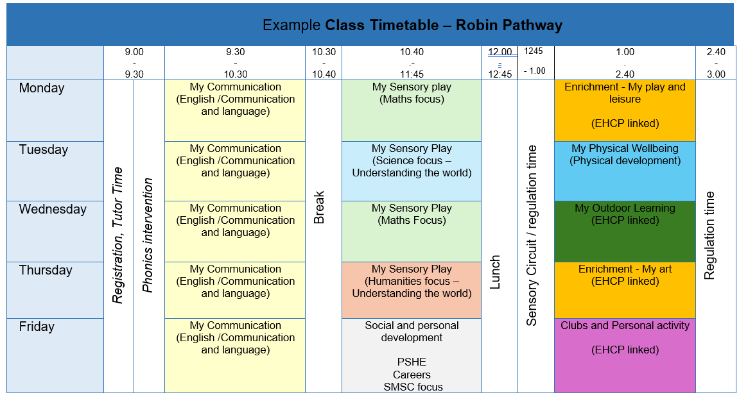

**Overview of timetable areas and where these are drawn from**

|  |  |
| --- | --- |
| **Curriculum area** | **Focus** |
| My Sensory Play | Solitary play, Parallel play, Shared play, Turn taking play, Co-operative play  With a linked theme to a subject area.  Linked to EQUALS informal scheme |
| My Communication | Imperative communications, Declarative communications , Formal social interaction with familiar People, Peer to peer communications,  Alternative and augmentative communications  Linked to EQUALS informal scheme |
| My Physical Well-being | Sensory integration and sensory circuits, Other play-based activities, Aquatics, Mental Health and Well-being, Relationships and sex education  Linked to EQUALS informal scheme |
| Enrichment | Linked to EQUALS informal / semi-formal schemes - My art and my play and leisure |
| My Outdoor School | Starting out, Orienteering, Shelter building, Using and open fire Cooking outdoors  Linked to EQUALS informal scheme |
| Story time / phonics | Shared / group reading of a story / Rocket phonics specific intervention. |
| Social and personal development | Linked to SEN PSHE association framework.  Linked to OFG Careers scheme / RE locally devised scheme |

**Kestrel pathway example timetable**

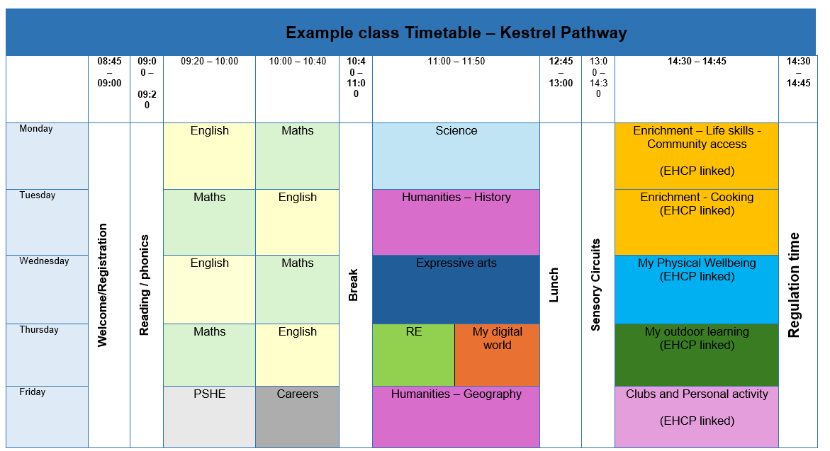

**Overview of timetable areas and where these are drawn from**

|  |  |
| --- | --- |
| **Curriculum area** | **Focus** |
| English | Reading, writing, speaking and listening form the background of English adapted from Hamilton Trust schemes – NC Years 1-4 |
| Maths | All functional aspect of maths following an adaptive curriculum based on The National Curriculum- adapted from White Rose Maths schemes – NC Years 1-4 |
| Science | Biology, Chemistry, Physics and scientific enquiry are taught through the National Curriculum, adapted from developing experts schemes - NC Years 1-4 |
| My Physical Well-being | Sensory integration and sensory circuits, Other play-based activities, Aquatics, Mental Health and Well-being, Relationships and sex education – Aligned to Equals Semi / formal activities. |
| Humanities -  History and Geography | Broad and aspirational topics based on the National Curriculum – adapted from Oak Academy schemes -. NC Years 1-4 |
| Expressive Arts | Explorative session linked to an artist focus, cultural works or creative media – Adapted from oak academy schemes – adapted from oak academy schemes -. NC Years 1-4 |
| Enrichment | Student focused personal development activities mapped against individual EHCP targets examples of topics might include - My Travel training, My shopping, My cooking etc. |
| My Outdoor School | Starting out, Orienteering, Shelter building, Using and open fire Cooking outdoors – Linked to EQUALS formal / semi-formal schemes. |
| Reading | Personalised experiences of reading, Focus texts, phonics, age-appropriate text / picture books / sight reading |
| RSHE | Linked to SEN PSHE association framework |
| Careers | OFG careers scheme |
| RE | Linked to NATRE - RE today scheme. |

**Eagle pathway example timetable**

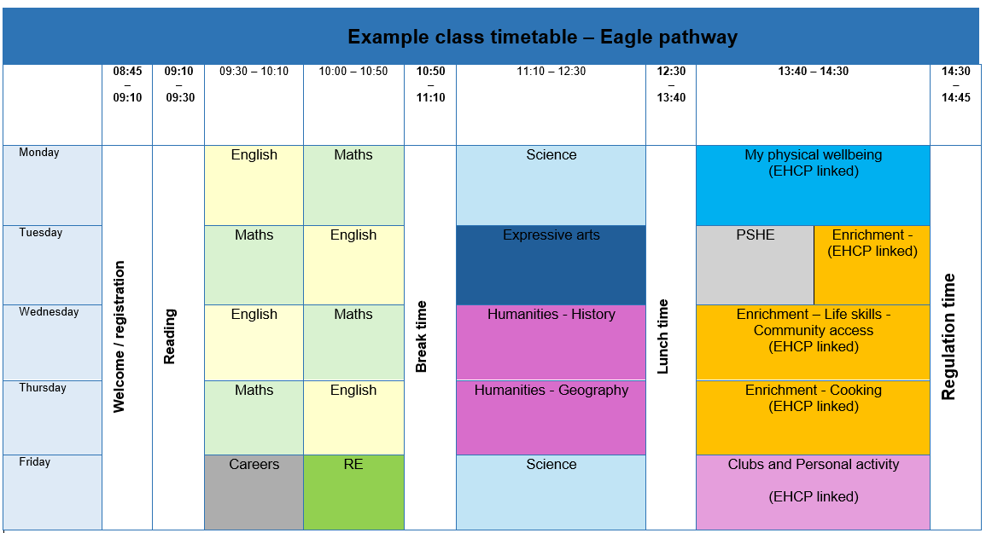

**Overview of timetable areas and where these are drawn from**

|  |  |
| --- | --- |
| **Curriculum area** | **Focus** |
| English | Reading, writing, speaking and listening form the background of English adapted from Hamilton Trust schemes – NC Years 5+ or SUTE Entry level (KS3 onward). |
| Mathematics | All functional aspect of maths following an adaptive curriculum based on The National Curriculum- adapted from White Rose Maths schemes – NC - Years 5+ |
| Science | Biology, Chemistry, Physics and scientific enquiry are taught through the National Curriculum, adapted from developing experts schemes -. NC Years 5+ |
| Enrichment | Student focused personal development activities mapped against individual EHCP targets examples of topics might include - My Travel training, My shopping, My cooking etc. |
| Humanities – History and Geography | Broad and aspirational topics based on the National Curriculum – Adapted from Oak Academy schemes - NC Years 5+ |
| Expressive arts | Explorative session linked to an artist focus, cultural works or creative media – Adapted from oak academy schemes -. NC Years 5+ |
| Reading | Personalised experiences of reading, Focus texts, age-appropriate texts monitored through accelerated reader. |
| RSHE | Linked to SEN PSHE association framework. |
| RE | Linked to NATRE - RE today scheme. |
| Careers | OFG careers scheme |

## **B.2 Curriculum Delivery**

### **Structure of the School Day**

The school opens to pupils at 8:45am, and pupils go home at 2:45pm. The school day is carefully planned in each class, according to the needs of pupils. An example of a typical students timetable can be found within the pathway overviews of the previous section of this policy.

### **Schemes of Work and Lesson Planning**

Curriculum planning will be dependent on which of pathways that students are accessing as outlined in the previous section. On a general level, the Robin Pathway follows the EQUALs informal curriculum. The kestrel and eagle pathways follow subject specific planning, which should be linked to the national curriculum where possible, at appropriate levels of challenge for students within the group. Additionally, these pathways also follow some elements of the EQUALs semi/formal pathways for areas such as my physical wellbeing or my outdoor learning.

Each teacher is required to have long term (yearly overviews) and medium-term planning (half termly overviews) for the class group that they are delivering. For subject learning linked to the National curriculum there are full entry to exit sequenced pathways to follow. Due to the play-based nature of the EQUALs curriculum longer term planning is not always possible in the same way as subject specific planning and will often be adapted on demand due to the smaller steps that students will progress at.

This planning will be followed by all teaching staff and their delivery monitored by the senior team. Planning sets out how the content of the pathway is structured, so that pupils’ skills, knowledge and understanding are developed progressively, and how the teaching is organised. (See additional assessment policy).

In order to best meet individual pupil and class needs, teachers have the autonomy to plan individual lessons, or sequences of lessons, in different ways. The senior team ensures that planning is carried out to a high standard, in sufficient detail to ensure that pupils achieve high standards and make optimal progress. Teachers are expected to evaluate their planning on a regular basis for all subjects this is supported by the senior team.

### Homework

Where it used correctly, homework can be a valuable aid to learning. Used in the wrong circumstances, it can be counter-productive to an individual’s progress, and their attitude to school. At Bestwood Village School we take an entirely individualised approach and will agree with parents and carers the volume and frequency of homework, in most cases this will not be appropriate due to transition from home to school and vice versa often being a barrier for learners with and ASC diagnosis. However, we encourage all parents and carers to provide opportunities for communication build and reading activities at home, following either the school scheme, or materials in the home. We also know that pupils on the autism spectrum often find it difficult to generalise learning, i.e. transfer newly acquired skills to different settings, and so we also ask parents discuss appropriate activities with their class teacher who will be in the best position to offer advice around a range of learning activities.

## B.3 Overcoming Barriers to Learning

### Sensory Processing

At Bestwood Village School there is recognition of the sensory differences, difficulties and challenges many pupils with ASC face daily. There is an understanding of how this can affect learning and behaviour and the focus of the ASC Curriculum is to reasonably adjust all aspects of school life in order to meet the student’s sensory needs.

Pupils with ASC often find it difficult to process and organise the different sensory input they receive. This can make it difficult for them to perform the many complex tasks necessary for learning and functioning in real life situations. The ASC Curriculum at Bestwood Village School places a great deal of emphasis on sensory processing, allowing the student to thrive in an environment that aids learning and supports the student to organise and process sensory input, and to use that input to respond. Each learner’s sensory processing system may be hypo or hyper-sensitive to one or all sensory channels, and some experience extremes of both across their sensory profile.

### The Learning Environment

The school is aware that a calm, purposeful and structured learning environment is essential in promoting high standards and good working practices. Displays of pupils’ work, stimulus materials and appropriate resources are very important in setting standards, raising expectations and play a key role in effective behaviour management. However, given the needs of or pupils, it is important that such displays are limited to the designated boards in each room, and never on the ‘front’ wall of the classroom unless utilised as part of a lesson’s activities. All class teachers and teaching assistants are expected to manage their display areas effectively and to contribute to displays in public areas of the school.

The structure and organisation of the classroom is also an important factor in developing effective working methods and a positive ethos. Whilst this is left to individual teachers and their teams, it is expected that classrooms are orderly environments where pupils can work effectively, comfortably and most importantly of all – safely. It is crucial that adequate resources are provided and are accessible, and that pupils are encouraged to treat classrooms, workshops and any other learning environments with respect.

### Applied Classroom Strategies

The following strategies are suitable for all pupils, particularly those with sensory differences:

* The learning areas are adapted so there is less sensory stimulus so that pupils can work at times without distraction, and they don’t distract others.
* There are designated internal and external breakout spaces where pupils can go if they need a sensory break, or time and space to relax. These areas are separate from the classroom and include outdoor spaces.
* As part of the curriculum each sensory difficulty is considered, to provide a carefully planned and reasonably adjusted learning environment.

### Visual Processing

* Clearly displayed timetables (visual and interactive), which are changed on a day-to-day basis.
* Keywords/Topic vocabulary clearly labelled areas and resources clearly labelled with expectations and objectives.
* If required, pastel paper and/or coloured overlays are available to reduce visual stress and help organise and track text.
* Fewer displays are used around the classroom to avoid visual over stimulation and so emphasis can be put onto the displays that are used.
* The main ‘teaching wall’ (typically where the screen and teacher desk are located) does not contain any displays or excess visual distraction.

### Auditory processing

* Language is reduced and simplified as far as possible and should always be supported with visuals where appropriate. Idiomatic, sarcastic or metaphorical language is avoided where possible, unless the speaker is also giving an explanation of their choice of words (e.g. explaining humour to a pupil),
* Processing time is given to pupils when information is presented verbally,
* Ear defenders are available for pupils in classrooms and the hall,
* Sensory breaks are permitted, where it is clear noise is causing, or likely to cause, distress. Sensory circuits are scheduled after non-structured time such a break and lunches when student can find transition back in to learning can be difficult.

### Proprioceptive/Vestibular Processing

At Bestwood Village School each lesson is reasonably adjusted, including splitting up lessons that otherwise involve a lot of sitting. Some pupils are allowed to (and encouraged to) stand and/or walk within a lesson, if it is felt that this promotes focus, calmness and engagement – learning may often be observed taking place outside of classrooms supported by teachers or TAs.

Whenever possible we spilt lessons to stimulate proprioceptive, vestibular responses and in any lesson, we emphasise a period of focused learning, offering additional time in an alternative learning activity which can involve movement or other educational stimulation. Individual pupils may be supported by an adult to move in or out of the classroom, in agreement with the class teacher.

### Whole Class Strategies

Class teams ensure consistent routines, rules and boundaries are assessed and reassessed on a weekly basis. They meet regularly to assess whether interventions are working (and tailor support if necessary) for each individual student and invite support from SLT or the multi-disciplinary team as appropriate.

### Specialist Staff

### 

Teaching and support staff at Bestwood Village School are continuously trained in both delivery of the individualised Curriculum, and in understanding the specific emotional and social needs of the pupils in a therapeutic nurturing environment. Staff work closely in collaboration with multi-disciplinary teams including specialist health practitioners, in particular speech and language therapists, occupational movement therapists and mental-health professionals, to provide a unique package of support which offers the best possible outcomes for pupils with autism both educationally and therapeutically.

Bestwood Village School has high ambitions and aspirations for pupils with autism to reach their full potential and to be included in school and society. The school recognises the importance of working in a multi-disciplinary way to promote pupils’ independence both at school and into adult life.

### Gifted Pupils

A small number of pupils may display special talents, skills, expertise and understanding areas. These include both high levels of ability in specific areas of the curriculum as well as activities / intense areas of interest beyond the curriculum - sporting prowess or musical ability, for example. It is the responsibility of all staff to identify such pupils, to encourage their interests and to make appropriate provision for them.

Such provision includes planning classroom-based work which genuinely stretches such pupils, and additional challenges and experiences offered through clubs, interest and support groups, and opportunities to participate in external groups, societies, teams and organisations and external visits. Opportunities to celebrate such success include commendations in school celebrations, letters of acknowledgement sent to parents and carers and records held in student’s records of achievement.

### Educational Visits

Planned, structured experiences for learners outside of the classroom and school environment add to everyone’s overall learning experience. Intrinsic to these opportunities will be a thoughtful focus on personal development, and Educational Visits are a very important area of the whole school curriculum.

Teachers are encouraged to make use of community facilities in the local community and further afield. Access to a range of environments not only supports and enriches subject specific learning, but also promotes the development of cultural capital, and meets many of the requirements of the ‘Independence and Community Participation’ strand of our ASC curriculum.

## B.4 Roles and Responsibilities

**The Headteacher/ Curriculum Lead will ensure that:**

* They have an oversight of curriculum structure and delivery within the school.
* Detailed and up-to-date schemes of learning are in place for the delivery of courses.
* Schemes of learning are monitored and reviewed on a regular basis.
* Levels of attainment and rates of progression are discussed with teachers on a regular basis and that actions are taken where necessary to improve these.
* Overall trends in progress and attainment inform strategic school development planning.

**Teachers will ensure that:**

* Long term planning is in place for all areas. Schemes of learning are designed using the school pro-forma and will contain curriculum detail on context, expectations, key skills, learning objectives, learning outcomes, learning activities, differentiation and resources.
* There is consistency in terms of curriculum delivery. Schemes of learning are in place and used by all staff delivering a particular subject area /focus area.
* Where necessary an appropriate combination of unit awards will be offered which best suit the needs of learners.
* Assessment is appropriate to the pathway and the pupils following particular paths. There should be consistency of approach towards assessment.
* Pupil performance data is reviewed on a regular basis to ensure that any necessary changes in terms of curriculum delivery are planned and carried out in a timely fashion.
* Ensure that the school curriculum is implemented in accordance with this policy.
* Keep up to date with developments in the subject areas that they deliver.
* Have access to, and be able to interpret, data on each pupil to inform the design of the curriculum in order that it best meets the needs of each cohort of pupils.
* Share and exchange information about best practice amongst their colleagues in different schools and through external networks, resulting in a dynamic and relevant curriculum.
* Participate in high quality professional development, working with other teachers to develop their skills in understanding the learning needs of their pupils and how best to address those needs and engage them.
* Work in partnership with other agencies to provide an appropriate range of curriculum opportunities.
* Actively support pupils in their progress through the new curriculum.

**Pupils will**:

* Be treated as partners in their learning, contributing to the design of the curriculum.
* Have their individual needs addressed, both within the school and extending beyond the classroom into the family and community through a curriculum which offers breadth, support, and challenge.
* Be given additional support if they start to fall behind in their learning, helping them get back on track quickly.
* Receive coordinated support to enable them to make the appropriate curriculum choices

**Parents and carers will**:

* Be consulted about their children’s learning and in planning their future education.
* Be confident that their child is receiving a high-quality education that is designed to meet their learning needs and which will equip them with the skills they need to thrive throughout their lives.
* Be informed about the curriculum on offer and understand the rationale behind it.
* Support learning at home where possible.

### **Section C – Impact**

#### **C.1 Pathway Assessment**

##### Pathways A – Robin / Kestrel Pathways (Informal/Semi formal)

##### 

Pupils are assessed on the Robin pathway using a combination of;

* The AET Progression Framework which provides an extensive ‘bank’ of learning intentions based on an understanding of autism and the challenges that pupil may face within education settings. It is by no means exhaustive and we tailor learning intentions according to each individual’s needs.
* The Engagement Model, WSP step, Routes for Learning (Welsh DfE), Derbyshire Small Steps, Solar levels all feed into the Assessment Books for pupils
* Outcomes found within the long-term intentions of the informal / semi-formal EQUALs curriculum.
* Rocket phonics progression.

Non-subject specific elements of the Kestrel Pathway (Semi-formal) are also assed using these criteria. – e.g. My outdoor school, my physical wellbeing etc.

Progress against outcomes are grouped into the following categories.

|  |  |
| --- | --- |
| **Emerging** | Pupil has been exposed to activities to facilitate progression towards an outcome but there is not yet evidence towards meeting the AET framework criteria / development matters criteria / EQUALS criteria / EHCP outcome. |
| **Developing** | Pupil has shown some evidence towards meeting the AET framework criteria / development matters criteria / EQUALS criteria / EHCP outcomes but this has not yet been frequent enough to full meet the target area. |
| **Secured** | There is evidence that the pupil has fully met the AET framework criteria / development matters criteria / EQUALS criteria / EHCP outcome. |
| **Mastered** | Pupil has shown full evidence to meet the AET framework criteria / development matters criteria / EQUALS criteria / EHCP outcome and can independently evidence without prompting. |

##### Pathways B/C – Semi-formal/ Formal - Kestrel / Eagle

These pathways are assessed formally through assessment books that draw from WSP levels, Route for Learning (Welsh DfE), SOLAR levels, B-Squared and National curriculum statements. Where possible, teachers are expected to evidence the targets met for all subjects taught to that pupil. Where appropriate the assessment mechanisms of the informal/semi-formal pathways will also be utilised.

Teacher should make ongoing judgements, which then articulates next steps and further development points. Targets that have been met and evidenced are then peer moderated to ensure the correct judgements have been made; this is done on a termly (mid-yearly in 2024/25) basis. Progress is categorised as Emerging, Developing, Securing or Mastering; where progress is Securing or Mastering no further work is required. However, where progress is slow, a second moderation takes place whereby a member of SLT will support and action where applicable.

|  |  |
| --- | --- |
| **Emerging** | Student has not met or demonstrated very limited progress towards the specified learning criteria. Support and prompts still required. |
| **Developing** | Evidence of some progress towards the learning criteria, lower level of prompt or support required. |
| **Securing** | Has met the learning criteria and can demonstrate understanding independently. |
| **Mastering** | Has exceeded the learning criteria and can demonstrate to others / apply in an unfamiliar context. |

Some of our pupils on this pathway may work towards elements of a unit award / accreditation in on or more specific subjects

#### **C.2 EHCP assessment**

Judgments and assessment against a pupils EHCP plan are monitored through Evidence for Learning, this is supported by pupils PLGS (Personalised learning goals) that break down the EHCP key stage target into smaller steps that allow a student to make focused progress over each term. Evidence is uploaded in real-time; time stamped and show a learning journey over time.

* Individualised EHCP outcomes – broken down into small achievable steps across each terms PLG’s

Ongoing judgements are made using the same E, D, S, M levels as used in curriculum subjects with the following reference guidance for teachers:

#### **C.3 Quality Assurance**

The quality of education provided to pupils at Bestwood Village is subject to regular and varied assurance activities. These include but are not limited to:

* Lesson Visits.
* Pupil progress review / termly reporting
* Termly supervisions for all teaching and teaching assistant staff.
* Planning reviews
* Coaching sessions
* Work scrutiny, including marking and assessment, and ‘deep dive’ activities.
* Moderation with leaders from other schools within OFG.
* Obtaining of stakeholder voice.

Please refer to Bestwood Village School quality assurance policy for further details of activities.

#### **C.4 Reporting to Parents**

The primary means of reporting on progress to parents is via the Annual Review process, in which detailed feedback is given in relation to the short and long-term objectives identified in Section E of their son or daughter’s Education, Health and Care Plan.

However, parents are also kept informed of the breadth, depth and quality of the education to their son or daughter via:

* Termly (Mid yearly in 2024-25) reporting to parents
* Frequent home-school liaison through;

Regular Class Dojo (or similar) updates and messages

School website

Parent Portal