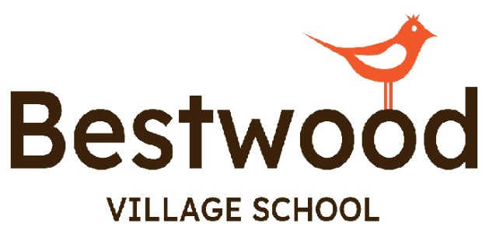

PUPIL PREMIUM STATEMENT

Next Review Date: July 2025

Version | Date | Updated By
1.0 | July 2024 | C. Bailey
1.1 | Feb 2025 | A Scotney

Pupil Premium

Pupil Premium is additional government funding for pupils who are either looked after children or perceived to come from disadvantaged backgrounds and therefore qualify for Free School Meals. This funding is then used to boost the learning of pupils so that the gap between learners is narrowed and all pupils are then able to reach their full potential.
Evidence shows that the most effective schools achieve best outcomes through high quality teaching, strong leadership, a relevant and coherent curriculum, a culture of high expectations and targeted catch-up and enrichment activities. Intrinsic support in the basics can enable children from disadvantaged backgrounds to catch up with their peers. Schools also influence how parents support their child’s learning and behaviour as they grow older and their needs develop. They can also help parents understand the breadth of possibilities open to their child and how their child can achieve their aspirations.
Pupils who receive pupil premium funding will benefit from one or more of the following additional provisions:
- Therapy interventions
- Laptop / iPad or other assistive technology
- Counselling
- 1:1 intervention for Literacy and Numeracy
- Decreased class sizes
- Alternative individualised curriculum
- Purchase of additional equipment/software to support learning
- Revision guides
- Additional TA support
- Support for behaviour
- Cultural/enrichment trips
- Educational trips

This list is inclusive of but not limited to all the above.

Bestwood Village School:

Students attending Bestwood Village School are grouped into one of three different pathways, based on their needs, EHCP targets and levels of attainment. These are called the Robin, Kestrel and Eagle Pathways.

Robin is our informal pathway and allow our students to explore their sense of self. These programmes are designed to allow pupils to gain a better understanding of their individualised communication / sensory profiles, through a sensory play/ intensive interaction approach.

Our semi formal Pathway – Kestrel starts to introduce subject content linked where possible to the national curriculum, whilst still allowing pupils to gain a better understanding of their individualised communication / sensory profiles, through a sensory play/ intensive interaction approach. Students will eventually advance to qualifications in key stage 4 in this pathway including ASDAN awards /Entry levels.

Our formal pathway – Eagle, is designed for students working at a higher cognitive level, this pathway contains links to the National Curriculum. Students studying on this route will eventually advance to qualification routes in Key Stage 4 e.g. Entry levels / Functional Skills

In addition to pathways Robin, Kestrel and Eagle, all students will access an enhanced Enrichment program, where they will have access to the local community which form an integral part of their education and preparedness for adulthood. The enrichment program allows students to build on their own independence through travel training, shopping and food preparation.

A scheme of learning around Careers has also been established to support students in understanding the different roles in society and build job aspirations in those students that may go on to find employment. PSHE, RSE and RE will be delivered to students at an appropriate level to their educational needs and levels of understanding.

Key Principles for using the Pupil Premium Grant at Bestwood Village School
- Bestwood Village School has a commitment to raise achievements for pupils who are eligible for Pupil Premium and knows these pupils must make faster progress than non-eligible pupils and is determined to achieve this.

- Bestwood Village School never confuses eligible pupils with low ability and strives to ‘bring out the best’ in this group of pupils and support them to achieve the highest levels.

- Bestwood Village School creates an overall package of support aimed to tackle the range of barriers including attendance, behaviour, external factors, professional development focussing on improving outcomes for eligible pupils, improving the quality of teaching and learning, language acquisition, parental engagement, opportunities for first-hand experiences and development of literacy and numeracy skills.

- Bestwood Village School uses assessment systems to track and enable through analysis of data, the pupils who are under achieving and why.

- Bestwood Village School directs resources and interventions to accelerate progress of eligible pupils and close the attainment gap compared to their peers.

- Bestwood Village School uses data carefully to track the impact of targeted spending (interventions, projects, pedagogy) on attainment and progress of eligible pupils.

- The Headteacher has a clear overview of how funding is allocated and the difference it is making to the outcomes of pupils termly.

- Bestwood Village School ensures class teachers, phase leaders and subject leaders know which pupils are eligible for Pupil Premium so they can take responsibility for accelerating progress and accountability is shared across the school.

- The Local Governing Body is ambitious for pupils and closely monitors the school’s effectiveness in closing the gap between different groups of pupils.

