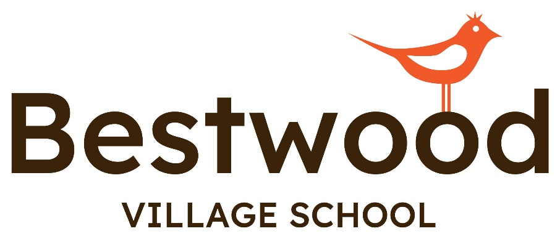

Updated February 2025 by Alison Scotney

Previous version July 24

Policy

Name:

Anti

-

Bullying Policy

Date of Last Review:

February 2022

Policy

Owner:

National Care Director

Date of Next Review:

February 2023

Date

First

Issued:

March 2017

1



**School**

**Careers & Employability**

**Skills**

**Policy**

**Update**

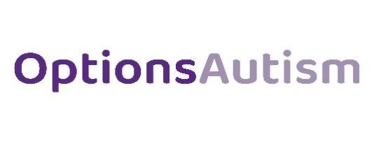

**Careers and Employability Skills Policy**

**Contents**

1. **Local Context**
2. **Intent**

# **3.0 Implementation**

# **4.0 Impact**

# **5.0 Special Educational Needs and/or disabilities**

# **6.0 Equality and Diversity**

# **7.0 Roles and responsibilities**

# **8.0 Careers Leader Contact Details**

# **9.0 Useful links**

# **10.0 Policy monitoring and review**

2

**Bestwood Village School**

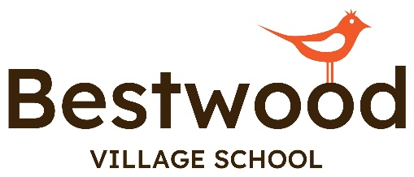

# **Local Context**

# Bestwood Village School is an Educational Establishment that caters for students and young people aged from 7-16. All students attending the school have an Autism diagnosis and are working significantly below their age-related expectations. Educational, Health and Care plans are in place to inform the provision planning to ensure that students are able to progress towards and meet their highly individualised and educational goals. In addition to their autism diagnosis, many students also have additional associated diagnosis', or medical considerations, such as Attention Deficit Disorder (ADHD) or Epilepsy.

# Students attending Bestwood Village School are grouped into one of three different pathways, based on their needs, EHCP targets and levels of attainment. These are called the Robin, Kestrel and Eagle Pathways.

# Robin is our informal pathway and allow our students to explore their sense of self. These programmes are designed to allow pupils to gain a better understanding of their individualised communication / sensory profiles, through a sensory play/ intensive interaction approach.

# Our semi formal Pathway – Kestrel starts to introduce subject content linked where possible to the national curriculum, whilst still allowing pupils to gain a better understanding of their individualised communication / sensory profiles, through a sensory play/ intensive interaction approach. Students will eventually advance to qualifications in key stage 4 in this pathway including ASDAN awards /Entry levels.

# Our formal pathway – Eagle, is designed for students working at a higher cognitive level, this pathway contains links to the National Curriculum. Students studying on this route will eventually advance to qualification routes in Key Stage 4 e.g. Entry levels / Functional Skills

# In addition to pathways Robin, Kestrel and Eagle, all students will access an enhanced Enrichment program, where they will have access to the local community which form an integral part of their education and preparedness for adulthood. The enrichment program allows students to build on their own independence through travel training, shopping and food preparation.

# A scheme of learning around Careers has also been established to support students in understanding the different roles in society and build job aspirations in those students that may go on to find employment. PSHE, RSE and RE will be delivered to students at an appropriate level to their educational needs and levels of understanding.

# **2.0 Intent**

The Careers Lead for Bestwood Village School is Michelle Bradshaw, supported by Alison Scotney - SENDCO. There is a collective responsibility for all staff to take ownership for the planning and delivery of personalised careers, employability, and economic understanding opportunities / experiences for all pupils.

We aim to develop children and young people’s understanding, awareness and skills linked to careers, employability, and economic understanding. Our aim is for all pupils to have meaningful experiences linked to their aspirations, interests, and developmental stage. We aim for pupils to have careers and employability learning opportunities and experiences as part of their core thematic topics or as part of whole school collapse curriculum days, off-site educational visits, and work experience.

We provide pupils with the knowledge, information, and skills to make informed choices about suitable “next steps” such as key life skills linked to employment, work experience, routes to voluntary or paid employment, qualifications, and accreditation to support further study. Bestwood enables pupils to receive accurate information, advice and guidance about all options and opportunities open to them and the progression routes to which those options lead.

We aim to ensure the following are explored appropriately in line with each pupils’ developmental stage, aspirations, and interests:

1) Have a stable careers programme

- An embedded programme of career education and guidance that is known and understood by pupils, teachers, parents/carers, employers, and other agencies.

2) Learn from career and labour market information

- Every pupil and their parents/carers, to have access to good quality information about future study options and labour market opportunities. This will include the support of an informed adviser to make the best use of available information.

3) Addressing the needs of each pupil

- Pupils have different career guidance needs at different stages. Opportunities for advice and support tailored to the needs of each pupil. Our careers programme ensures equality and diversity is embedded throughout.

4) Linking curriculum learning to careers

- All teachers and support staff link curriculum learning with careers, even on subject areas that may not be specifically occupation-led. For example, STEM subjects should have their relevance highlighted and linked to the wide range of future career paths. Learning programmes should also reflect the importance of Maths and English as a key expectation from employers.

5) Encounters with employers and employees

- Every pupil should have multiple opportunities to learn from employers about work, employment and the skills that are valued in the workplace. This will be through a range of enrichment activities, including visiting speakers, mentoring and enterprise schemes, and include pupils’ own part-time employment where it exists / is possible.

6) Experience of workplaces

Every pupil to have first-hand experiences of the workplace through work visits, work shadowing and/or work experience to help their exploration of career opportunities and expand their networks.

7) Encounters with further and higher education

- All pupils should understand the full range of learning opportunities that are available to them. This includes both academic and vocational routes, and learning in schools, colleges, universities and in the workplace.

8) Personal guidance

- Every pupil should have opportunities for guidance interviews with a careers adviser, this could be internal (a member Bestwood staff) or external, provided they are trained to an appropriate level. These will be available for all pupils and appropriate to the individual needs and developmental stage.

## 3.0 Implementation

At Bestwood we cater for children and young people in Key Stages 2, 3 and 4. However, we recognise that our pupils are developmentally at different stages and therefore will access curriculum content that is appropriate to this developmental stage not necessarily the chronological age of the pupil.

In summary, at Bestwood, pupils will be taught via group learning, individualised, whole school learning opportunities that focuses on;

* Teaching that develops pupils’ understanding of economic wellbeing linked to money, the use of it, different sources of income and financial choices that adults must make.
* Teaching that develops pupils’ aspirations linked to work and future careers.
* Teaching that develops pupils’ understanding of learning skills linked to positive employment skills.
* Teaching that highlights choices and pathways towards employment.
* Teaching that develops pupils’ awareness of employment right and responsibilities.

Current coverage across our three different pathways is outline below. As a new school, the careers programme was developed across Autumn 2024 term and launched formally into the Spring 2025 term. This scheme has been developed alongside the OFG central careers team and draws upon key criteria from the Careers Development Institute (CDI)

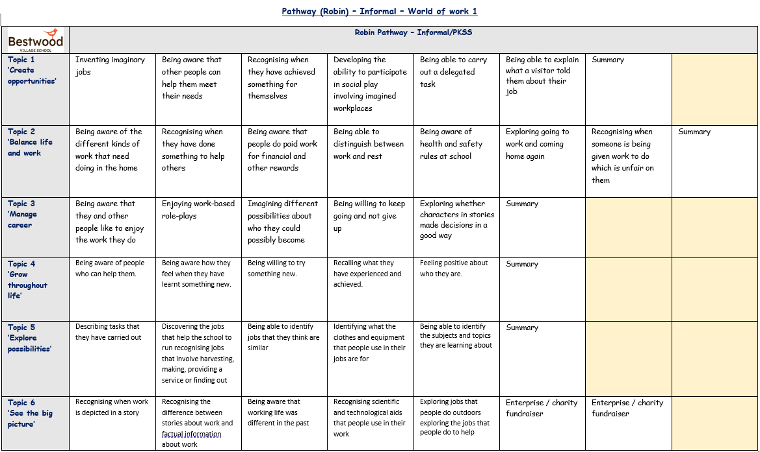

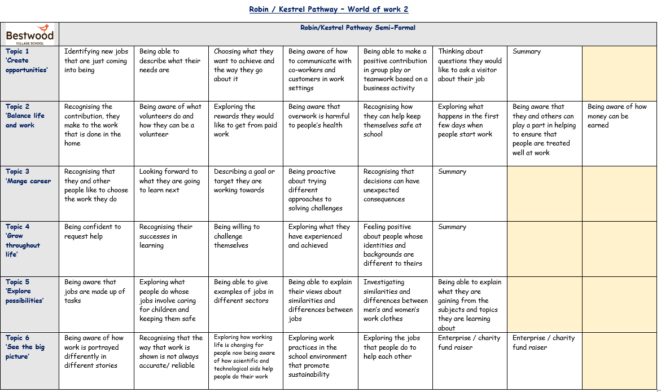

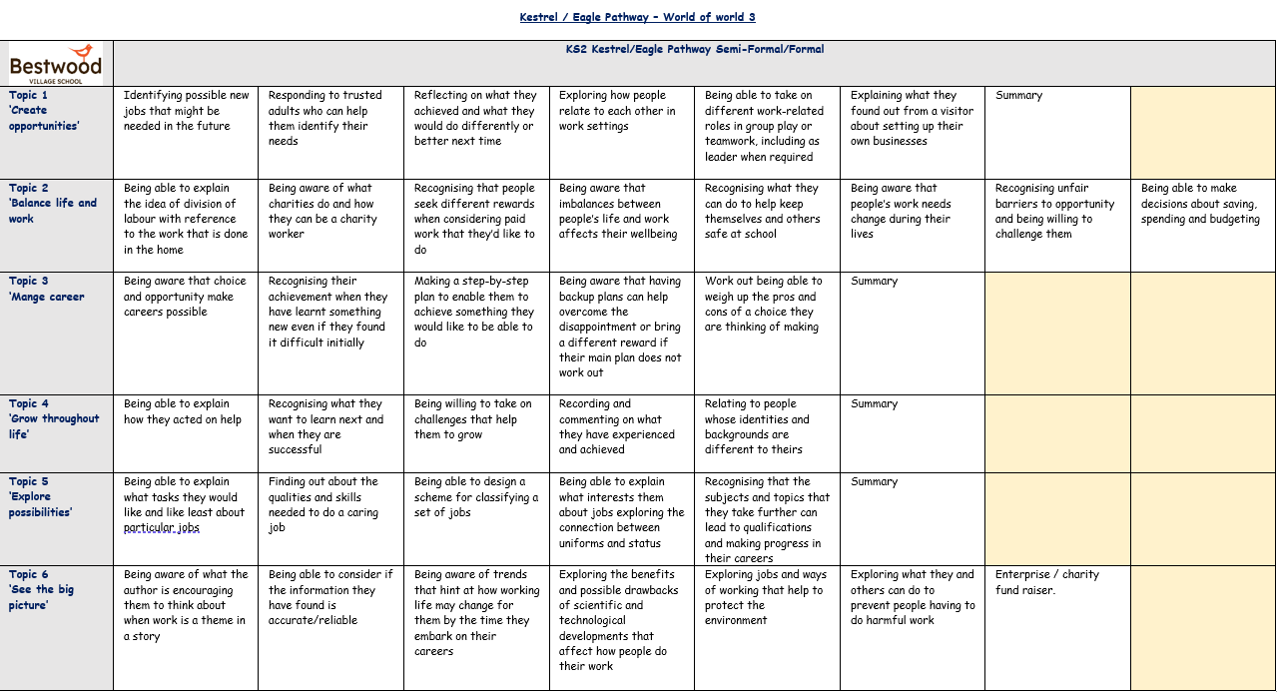

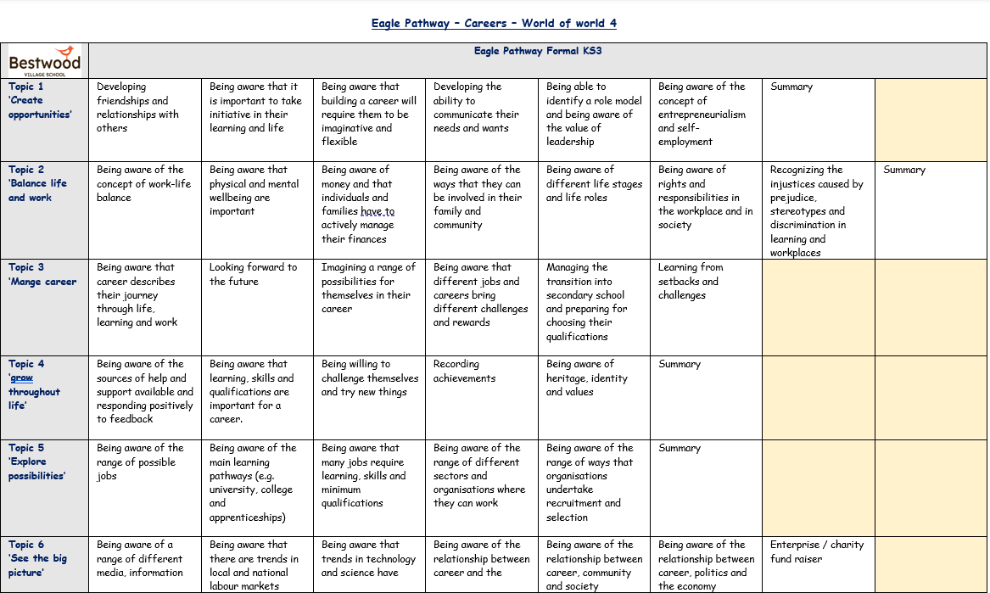

**PSHE Coverage of careers**

Careers coverage through the PSHE curriculum has also been highlighted below. This covers the three pathways as above as is linked to specific PSHE topics namely Economic Wellbeing, Learning skills and Work and career.

|  |  |  |  |
| --- | --- | --- | --- |
| **(PSHE) Careers & Employability Skills inc. Economic Wellbeing –**  **Long Term Planning Overview** | | | |
| **Curriculum Stage** | **Key Stage 2 – 4 (Chronological Age)** | | |
| **KS2** | **KS3** | **KS4** |
| **Informal** | * Economic wellbeing: Money **(PSHE)** * Economic wellbeing: Aspirations, work and career **(Careers & Employability Skills)** * Learning Skills **(Careers & Employability Skills)** * Work and Career **(Careers & Employability Skills)** | | |
| Personalised Careers Advice: Anna Leese - Independent Apprentice, Careers & Employability Advisor | | |
| **Semi-Formal & Formal** | * Economic   wellbeing: Money  **(PSHE)**   * Economic   wellbeing: Aspirations, work and career  **(Careers &**  **Employability**  **Skills)**   * Learning Skills **(Careers &**   **Employability**  **Skills)**   * Work and Career   **(Careers &**  **Employability**  **Skills)** | * Choices and Pathways **(Careers & Employability**   **Skills)**   * Work and Career **(Careers & Employability Skills)** * Employment rights and responsibility **(Careers & Employability Skills)** * Financial Choices **(PSHE)** | |
| Personalised Careers Advice: Anna Leese - Independent Apprentice, Careers & Employability Advisor | | |

Preparing for Adulthood Agenda

All pupils are supported by our commitment to the preparing for adulthood agenda. This begins at EHCP planning stage and links outcomes to the four key areas of Employment, Community Inclusion, Independent Living and Health. Throughout pupils’ time at Bestwood they will experience the following learning opportunities via the school’s commitment to the PfA agenda.

**Experience of Work**

We aim to adapt and support experience of work opportunities for all pupils – This will begin at the start of KS4.

Aims of Work Experience:

* To support and encourage an integrated experience of work programme aimed to support the developmental stage of each pupil
* To provide pupils with records/documents to provide evidence of their experience
* To provide pupils with direct experience of the world of work
* To give pupils first-hand experience of the relationships, routines and processes that are part of a working environment
* To develop work related skills and behaviours
* To contribute towards approved vocational and academic qualifications where applicable
* To prepare pupils for adult and working life
* To prepare pupils by discussing equal opportunities and challenging stereotypes

# Experience of work planning

* Pupil to meet with Careers Lead to discuss and identify a pupil’s choice of placement.
* Meeting with all education staff, care staff, supporting professionals, work experience provider. Risk assessment carried out.
* Careers Lead to contact suitable establishments, insurance checks and risk assessment completed.
* Diary/logbook to be kept by each pupil, showcasing achievements,
* Careers Lead to visit a pupil in placement.
* Evaluation – evaluate the placement successes and areas for improvement. We should discuss with the pupil what they achieved, identify skills they have improved and acknowledge what they have learned.
* Follow up – letter of thank you to be sent to employers by the pupil.

## 4.0 Impact

Every pupil at Bestwood has an individualised Communication / Sensory / Positive support Profile. These profiles are developed around the pupil’s interests and aspirations to help form relevant targeted outcomes that are reviewed and monitored on a termly basis to highlight and showcase progress made. These termly progress check points are used to then identify appropriate next steps within the pupils personalised Careers and Employability educational journey.

## 5.0 Special Educational Needs and/or disabilities

All pupils at Bestwood Village School have additional learning needs and all have an Education Health Care (EHC) Plan.

In order to make sure all pupils are able to access developmentally appropriate curriculum content all learning opportunities and resources are differentiated accordingly to needs of pupils.

The Deputy Head and SENDCO will work closely with all class teachers to determine if any additional support is required for an individual pupil to access the curriculum, ensuring any barriers are removed.

## 6.0 Equality and Diversity

We are committed to ensuring that all pupils have access to careers, employability skills and economic understanding education. Pupils are encouraged to follow career paths that suit their interests, skills, and strengths with the absence of stereotypes. All pupils are provided with the same opportunities and diversity is celebrated.

## 7.0 Roles and responsibilities

The Headteacher and Deputy Head and SENDCO are responsible for ensuring that PSHE – Careers, Employability Skills, Economic Understanding is taught consistently across the schools.

## Staff

Staff are responsible for:

* Delivering PSHE – Careers, Employability Skills, Economic Understanding in a sensitive way
* Modelling positive attitudes to PSHE – Careers, Employability Skills, Economic Understanding
* Delivering the careers topics as outline through dedicated sessions / form discussion.
* Monitoring progress
* Responding to the needs of individual pupils

## Pupils

Pupils are supported to engage fully in PSHE – Careers, Employability Skills, Economic Understanding and, when discussing issues related to this curriculum area they will treat others with respect and sensitivity.

Pupils are supported to engage in the careers learning pathway as outlined above through dedicated sessions, drop down days and form time discussions.

### 8.0 Careers Leader Contact Details

Alison Scotney (Sendco)

Alison.scotney@bestwoodvillageschool.co.uk

Michelle Bradshaw (Careers Lead)

Michelle.bradshaw@bestwoodvillageschool.co.uk

If you are a pupil, parent, teacher, external professional or an employer and would like any information about any aspect of our careers and employability curriculum please do not hesitate to contact Amy Chipunza who will be happy to discuss in detail our current offer.

Anna Leese – Independent Apprentice, Careers & Employability Advisor

[Anna.leese@ofgl.co.uk](mailto:Anna.leese@ofgl.co.uk)

At Bestwood Village School we have teamed up with independent careers advice service via Outcomes First Group [(www.outcomesfirstgroup.co.uk)](http://www.outcomesfirstgroup.co.uk/) and all our pupils have access to independent careers advice from Beckie Jones Independent Apprentice, Careers & Employability Advisor. She specialises in working with children and young people with Autism and other additional needs and works to support our pupils have accessible careers conversations.

### 9.0 Useful links

Impartial, high quality careers and labour market information can be found on the ‘links4careers’ section of the ‘ideas4careers’ website. Please follow this link; <https://ideas4careers.co.uk/resources/links4careers/>for a wealth of information and resources.

### 10.0 Policy monitoring and review

The senior leadership team monitor implementation of this policy termly and review this policy on an annual basis.



**We**

**are**

**part**

**of**

**the**

**Outcomes**

**First**

**Group**

**Family,**

**by working together we will build**

**incredible**

**futures by empowering vulnerable**

**children,**

**young people and adults in the UK**

**to be happy**

**and**

**make**

**their**

**way**

**in**

**the**

**world**